Grade 7 Accelerated · Unit 3 · Lesson 4  Negative Exponent Law  Question Bank 3.04 ANSWER KEY | Name  Date  Period

Show your work. Circle your final answer.
For questions 1 through 6, rewrite each expression as an equivalent expression with positive exponents. Do not evaluate.
1. 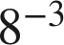


2. 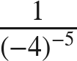

The power moves up and the exponent turns positive; the base keeps its sign.

3. 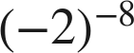
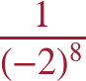
Keep the parentheses.

4. 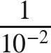


5. 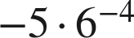
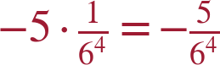
The −5 is a factor, not a base with an exponent; it stays where it is.

6. 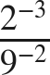

Each power swaps sides.

For questions 7 and 8, apply the negative exponent law, then the product or quotient of powers law, and evaluate.
7. Evaluate each expression.
a. 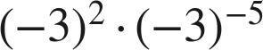
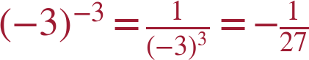
b. 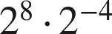

c. 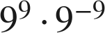


8. Evaluate each expression.
a. 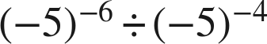
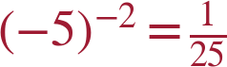
−6 − (−4) = −2; an even power of a negative is positive.
b. 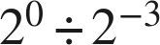

c. 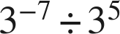
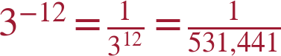

Opposite or reciprocal.
9. Four expressions are shown: , 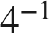, 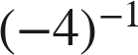, 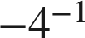.
a. Give the value of each one.
−4; 1/4; −1/4; −1/4
4⁻¹ is the reciprocal of 4. (−4)⁻¹ is the reciprocal of −4. −4⁻¹ is the opposite of the reciprocal of 4 — the same value as (−4)⁻¹ here, for a different reason.
b. Which of the four is the reciprocal of 4, and which is the opposite of 4?
 is the reciprocal of 4;  is the opposite of 4.

Working backwards.
10. Find the value of that makes each statement true.
a. 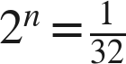
n = −5
b. 
n = −3
c. 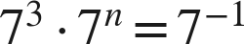
n = −4
3 + n = −1.

11. Which is the value of 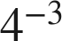 ?
○ A. 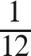
○ B. 
● C. 
○ D. 
C

12. Select ALL of the expressions whose value is 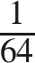.
☒ A. 
☒ B. 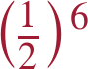
☒ C. 
☐ D. 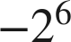
☐ E. 
☒ F. 
A, B, C and F

